**Project 2 - Bird Sight**

Nam Luu, Geoffrey Holland, Joshua Cohen, Laura Hawkins, Ben Lamkin

* **Selecting a topic**

150 Bird species - including pictures and location of the different birds

* **Finding a data set**

https://www.kaggle.com/gpiosenka/100-bird-species

* **Finding inspiration**

The group wanted to find a topic that strayed away from the virus and use that as a refresher while still being interesting and fun to help everyone get their minds off the current situation.

* **3 or 4 screenshots of relevant, “inspiring” visualizations that frame your creative fodder**

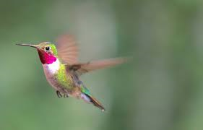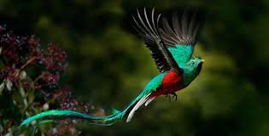

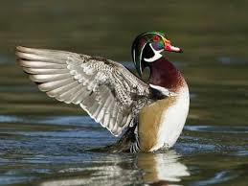

* **“Sketching” your ideal visuals**

Using plotly, google maps, box map, leaflet.

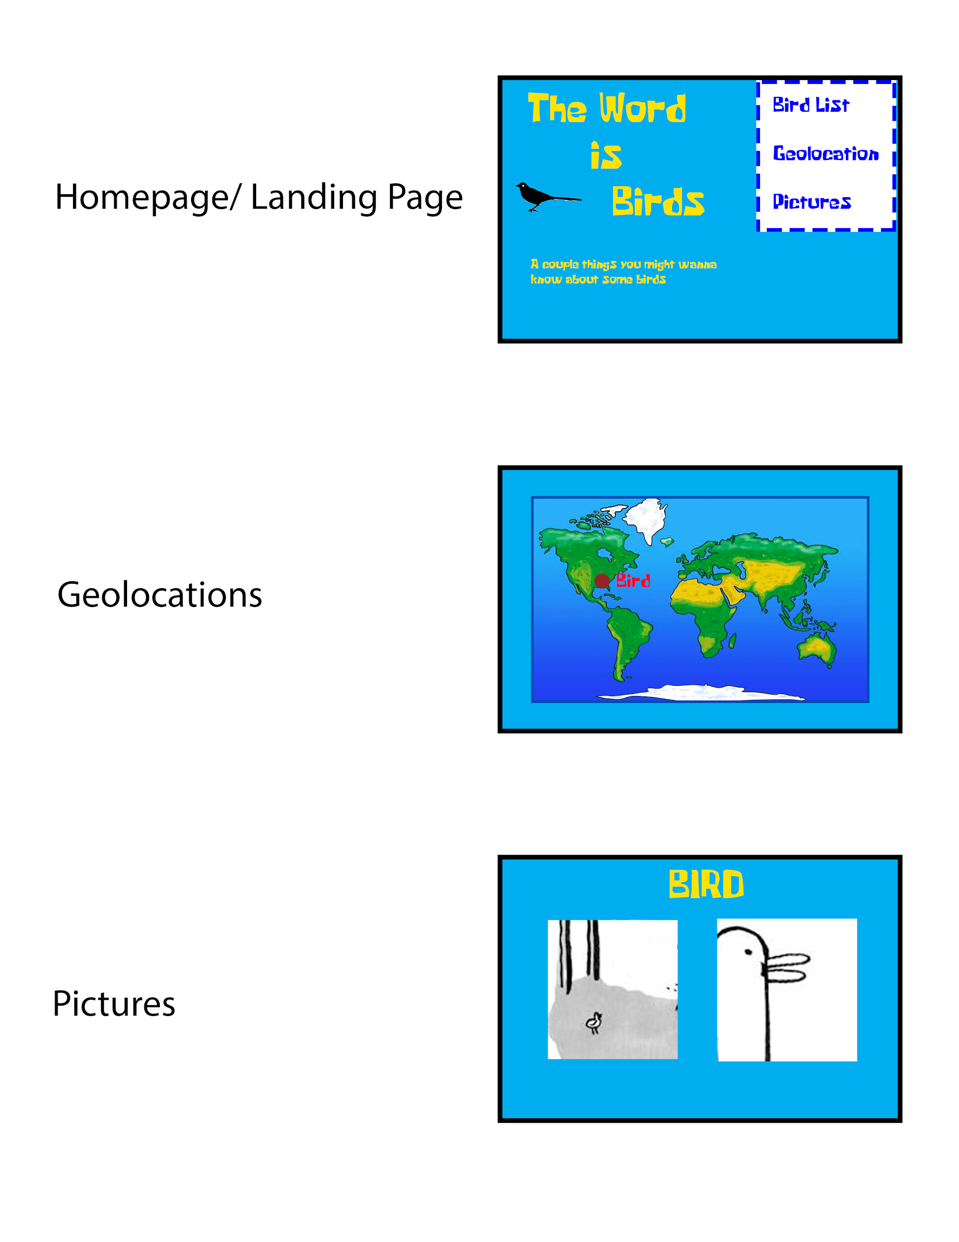

* **A link to the primary GitHub repository you’ll be housing your work in**

https://github.com/benjamindavidlamkin/Cacaw_Bird_Project